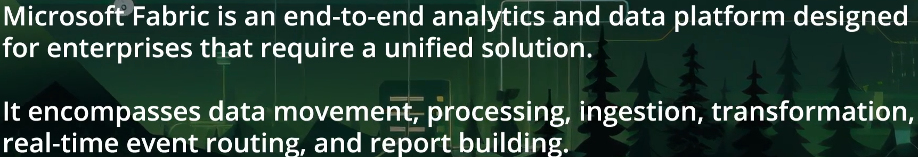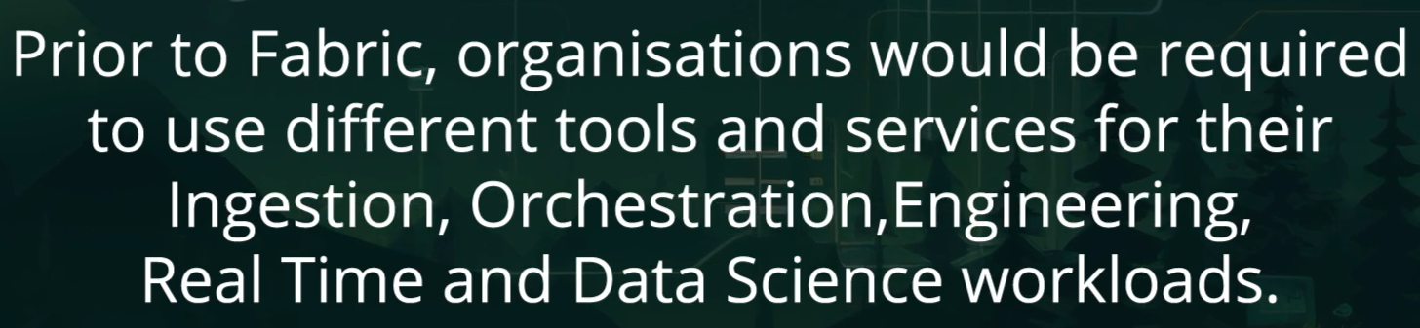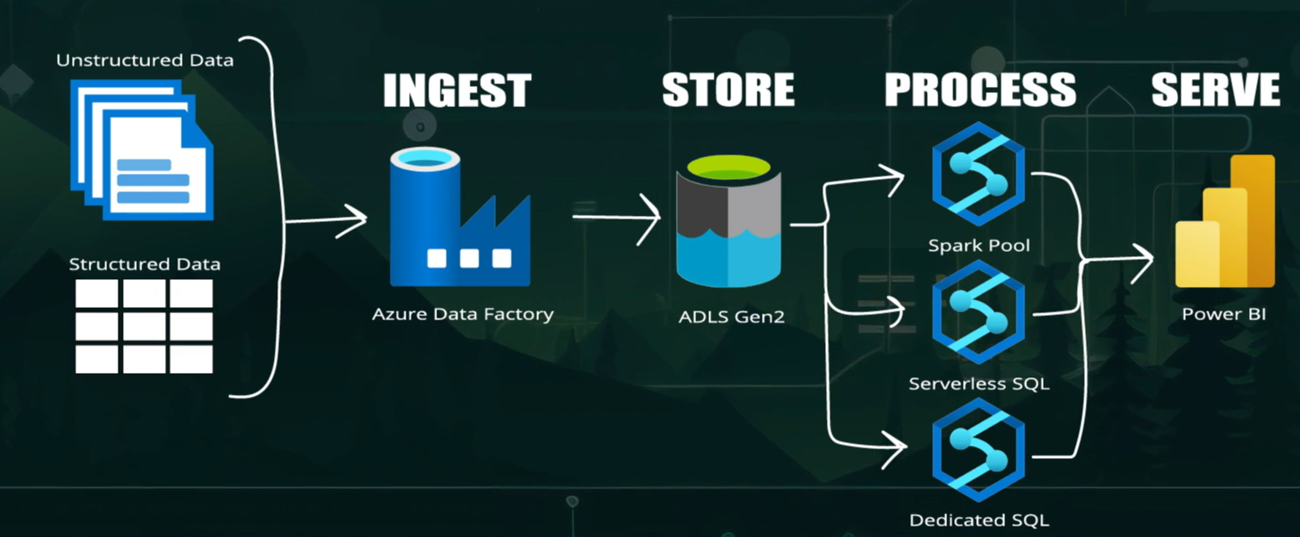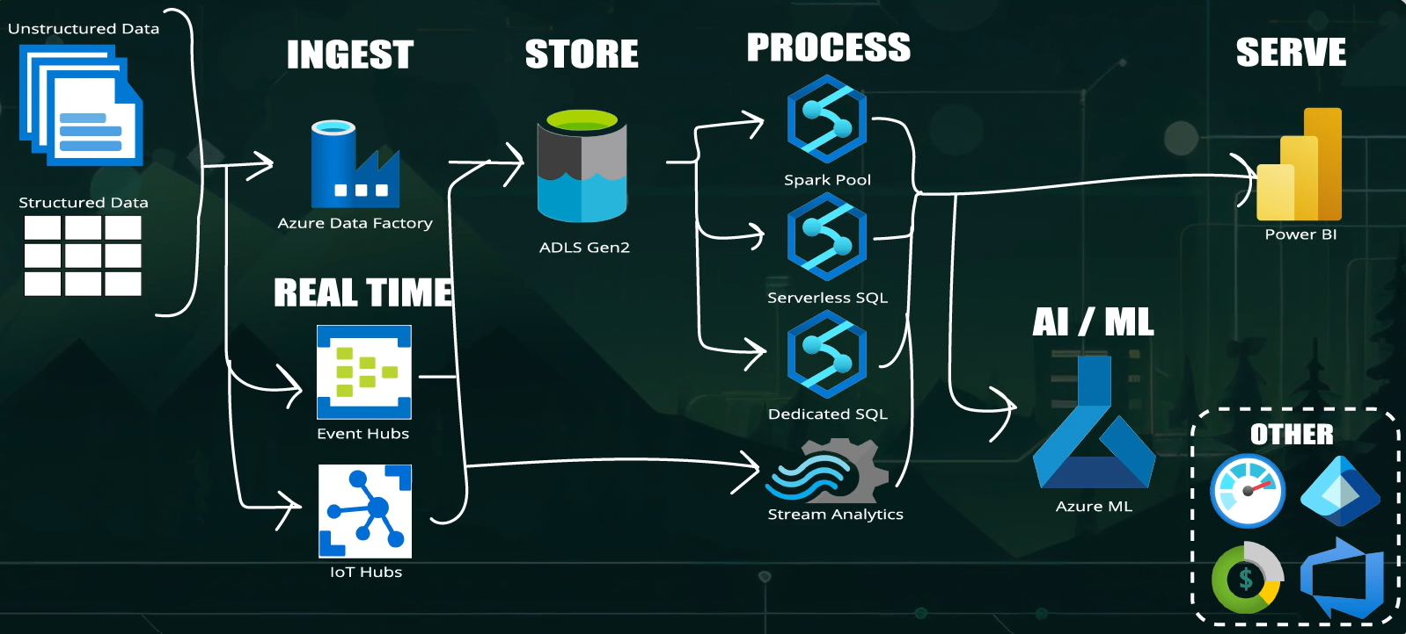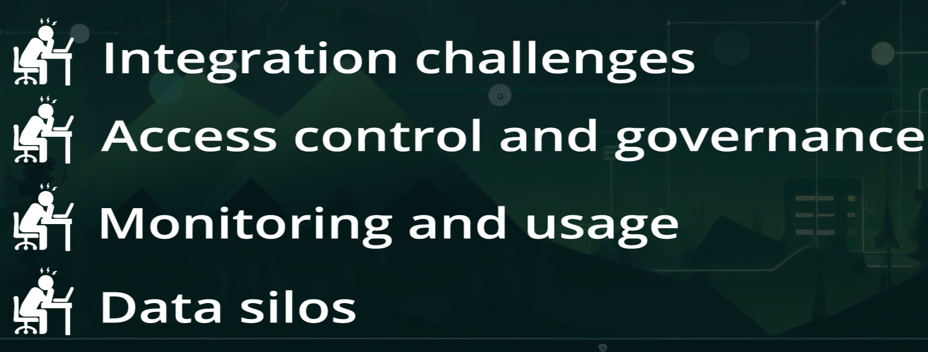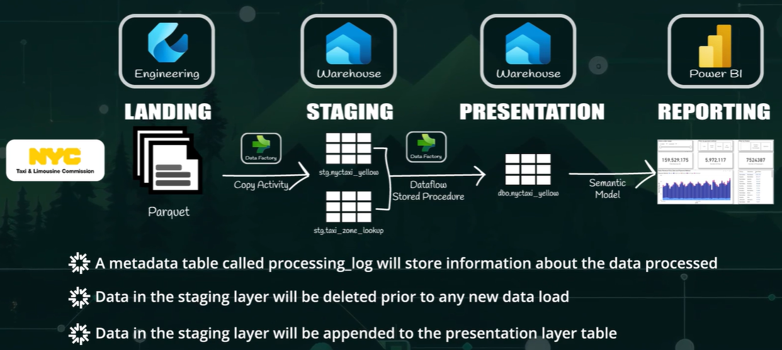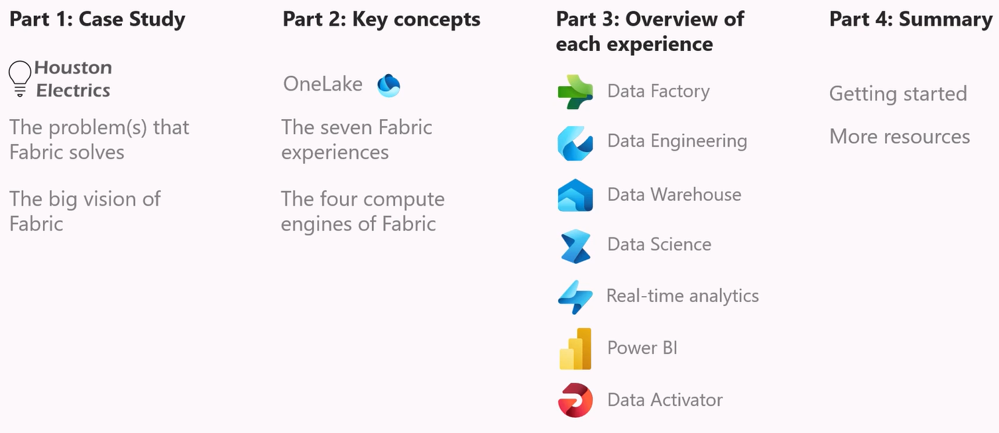

**Big picture: What is Microsoft Fabric?**

**Microsoft Fabric** is **one single platform** that covers:

**Data coming in → storing → processing → analysing → reporting**

Instead of using many separate tools, Fabric puts them all together.

| **Fabric item** | **Simple meaning** |
| --- | --- |
| Pipeline | Moves data (copy / schedule) |
| Eventstream | Handles live/real-time data |
| Lakehouse | Stores raw + processed data |
| Notebook | Cleans & transforms data |
| Warehouse | SQL analytics layer |
| Power BI | Reports & dashboards |

Data Source

↓

Pipeline / Eventstream

↓

Lakehouse

↓

Notebook

↓

Warehouse

↓

Power BI

**1️⃣ Pipeline – “Data mover & scheduler”**

**What it is (simple)**

A **Pipeline** is like:

“Copy data from here to there, on a schedule”

**HS2 example**

HS2 gets:

* Daily CSV files of **train delays**
* Weekly Excel of **construction costs**

Pipeline:

* Copies files from source
* Loads them into Fabric storage

Every night at 2 AM:

→ Copy train_delay.csv

→ Save into Lakehouse

✔ No coding  
✔ Drag & drop  
✔ Like Azure Data Factory

**2️⃣ Eventstream – “Live data”**

**What it is (simple)**

Used for **real-time streaming data**.

**HS2 example**

* Live sensor data from tracks
* Speed, vibration, temperature every second

Eventstream:

* Listens to live feed
* Sends data immediately to Lakehouse

Train speed updates every second

→ Eventstream

→ Lakehouse table (live)

✔ Real-time  
✔ No waiting for files

**3️⃣ Lakehouse – “Big data storage”**

**What it is (simple)**

A **Lakehouse** is:

One place to store **raw + cleaned data**

It stores:

* CSV
* JSON
* Parquet
* Big data

**HS2 example**

Lakehouse stores:

* Raw train delay files
* Sensor data
* Cleaned construction data

Files/raw/train_delays.csv

Tables/train_delays_cleaned

✔ Cheap storage  
✔ Handles large data  
✔ Used by engineers

**4️⃣ Notebook – “Data cleaning & logic”**

**What it is (simple)**

A **Notebook** is where you:

* Clean data
* Transform data
* Write Python / Spark logic

**HS2 example**

Notebook cleans:

* Missing delay reasons
* Wrong station names
* Converts timestamps

df = spark.read.table("train_delays_raw")

df_clean = df.dropna()

df_clean.write.saveAsTable("train_delays_cleaned")

✔ Used by Data Engineers  
✔ Heavy compute  
✔ Like Databricks

**5️⃣ Warehouse – “SQL analytics layer”**

**What it is (simple)**

A **Warehouse** is:

Clean, fast SQL tables for reporting

Business users don’t touch raw data.

**HS2 example**

Warehouse tables:

* Total delays per route
* Monthly cost per region
* On-time percentage

SELECT route, AVG(delay_minutes)

FROM train_delays_cleaned

GROUP BY route;

✔ Fast  
✔ SQL only  
✔ Used by analysts

**6️⃣ Power BI – “Reports & dashboards”**

**What it is (simple)**

Power BI:

* Creates dashboards
* Visualises data

**HS2 example dashboards**

* Delay heatmap by route
* Cost overrun by contractor
* Live train performance

✔ Executives use this  
✔ No coding required

**OneLake (behind the scenes)**

Fabric uses **OneLake**:

* One storage for everything
* No data duplication

You don’t manage it directly — Fabric does.

| **Lakehouse** | **Warehouse** |
| --- | --- |
| Stores raw + semi-clean data | Stores clean business data |
| Used by engineers | Used by analysts |
| Big data friendly | Fast SQL queries |
| Spark + SQL | SQL only |

**Think:**

* Lakehouse = kitchen ; Warehouse = dining table

**Beginner path (recommended)**

1. Learn **Warehouse (SQL)**
2. Understand **Lakehouse**
3. Touch **Pipeline**
4. Notebooks later
5. Eventstream last

**Simple end-to-end HS2 flow -** HS2 sensor data → Eventstream → Lakehouse → Notebook cleans → Warehouse models → Power BI dashboard

| **Fabric item** | **Real life** |
| --- | --- |
| Pipeline | Goods delivery schedule |
| Eventstream | Live train control room |
| Lakehouse | Warehouse storage yard |
| Notebook | Engineers fixing parts |
| Warehouse | Control room reports |
| Power BI | CEO dashboard |
| Term | One-line meaning |
| Data Lake | Cheap storage for any raw data |
| Lakehouse | Data Lake + tables + analytics |
| Dataverse | Business app data store |
| KQL Database | Fast engine for logs & telemetry |
| Warehouse | Clean SQL data for reporting |

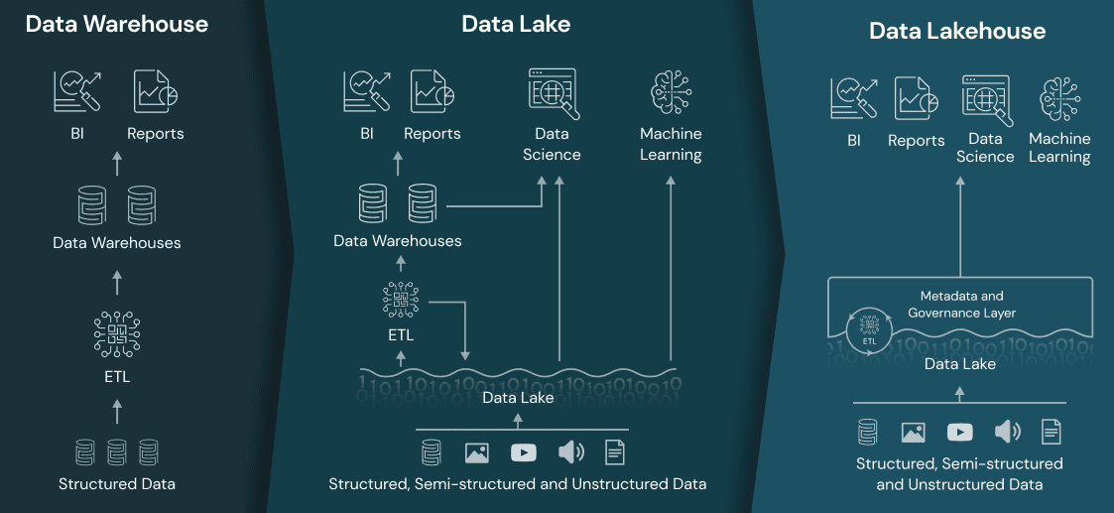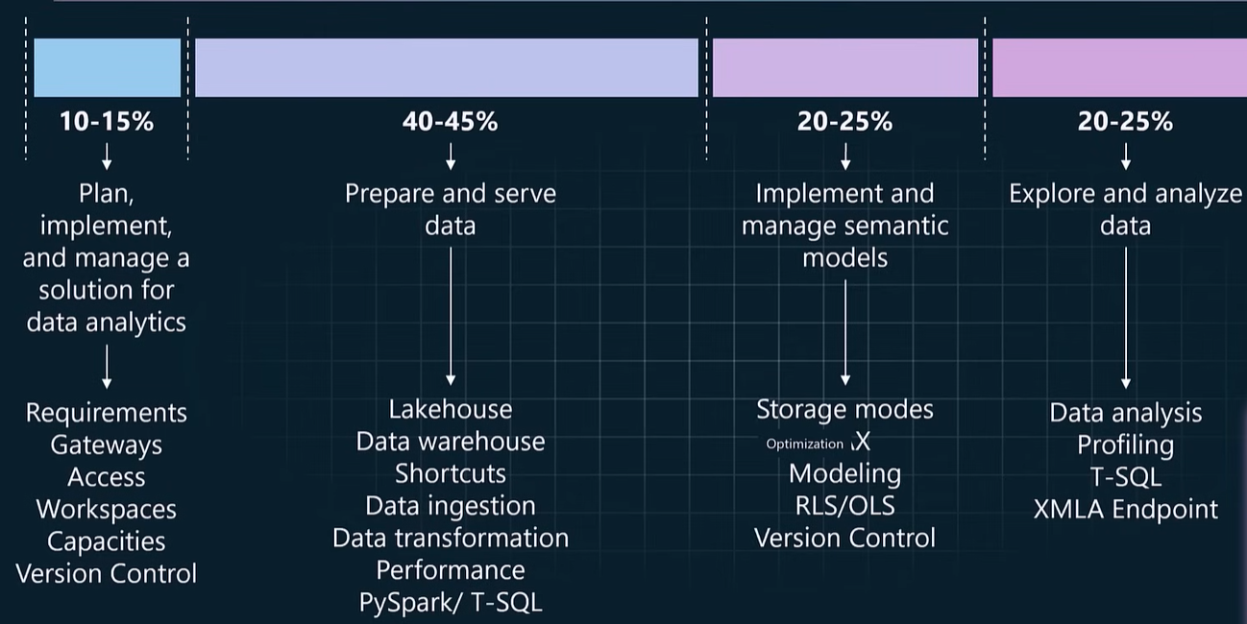

**1️⃣ Data Lake – “Raw storage only”**

**What is a Data Lake?**

A **Data Lake** is:

A **big storage area** for raw data in original format

In Microsoft world, this is usually  
**Azure Data Lake Storage**

**HS2 example**

HS2 stores:

* Raw sensor files
* CSVs from contractors
* JSON from ticket systems

Nothing is cleaned yet.

/raw/train_delays.csv

/raw/sensor_dump.json

**2️⃣ Lakehouse – “Smart Data Lake”**

**What is a Lakehouse?**

A **Lakehouse** is:

A **Data Lake** + **tables** + **analytics**

In **Microsoft Fabric**, Lakehouse is the **default working layer**.

**HS2 example**

HS2 Lakehouse contains:

* Raw files
* Cleaned Delta tables
* Spark + SQL access

Files/raw/train_delays.csv

Tables/train_delays_cleaned

**3️⃣ Dataverse – “Business app data”**

**What is Dataverse?**

**Microsoft Dataverse** is:

A **structured data store for business applications**

Used by:

* Power Apps
* Dynamics 365
* Low-code apps

**HS2 example**

HS2 business apps store:

* Incident reports
* Contractor details
* Employee assignments

Incident ID | Station | Severity | Status

**4️⃣ KQL Database – “Super-fast log analytics”**

**What is a KQL Database?**

Powered by **Azure Data Explorer**

Used for:

* Logs
* Telemetry
* Time-series data

Query language = **KQL (Kusto Query Language)**

**HS2 example**

Used for:

* Live train telemetry
* Sensor logs
* Failure events

TrainTelemetry

| where Speed > 120

| summarize avg(Speed) by Route

| **SQL** | **KQL** |
| --- | --- |
| Business data | Logs & telemetry |
| Rows & tables | Events & time |
| Warehouse | KQL Database |
| Finance reports | Monitoring & alerts |

Live Sensors

↓

Eventstream

↓

KQL Database (fast analysis)

↓

Lakehouse (historical storage)

↓

Notebook (clean & enrich)

↓

Warehouse (business SQL)

↓

Power BI

**Where Dataverse fits**

Dataverse runs **parallel**, not inline:

Power Apps (Incidents)

↓

Dataverse

↓

Fabric (optional analytics)

HS2 combines:

* Operational app data (Dataverse)
* Engineering data (Lakehouse)
* Telemetry (KQL DB)

| **If data is…** | **Use** |
| --- | --- |
| Raw files | Data Lake |
| Big data + analytics | Lakehouse |
| Clean business reporting | Warehouse |
| Business app records | Dataverse |
| Logs / sensors / events | KQL Database |

**Learn in this order ✅**

1. Warehouse (SQL)
2. Lakehouse (concepts)
3. Pipeline
4. Notebook
5. KQL Database
6. Dataverse (only if app-focused)

| **Term** | **Real world** |
| --- | --- |
| Data Lake | Storage yard |
| Lakehouse | Warehouse with workers |
| Warehouse | Office reports |
| Dataverse | HR system |
| KQL DB | Control room monitors |
| Term | Simple meaning |
| Azure | Microsoft’s cloud (like electricity + buildings) |
| AWS | Amazon’s cloud (same idea as Azure) |
| Snowflake | Cloud data warehouse (SQL analytics) |
| Databricks | Big data + Spark processing |
| OneLake | One shared data storage in Fabric |
| Microsoft Fabric | All-in-one data platform |
| SQL | Query business tables |
| KQL | Query logs & events |

